**Dinosaur - Wooden Animal Wall Mount**

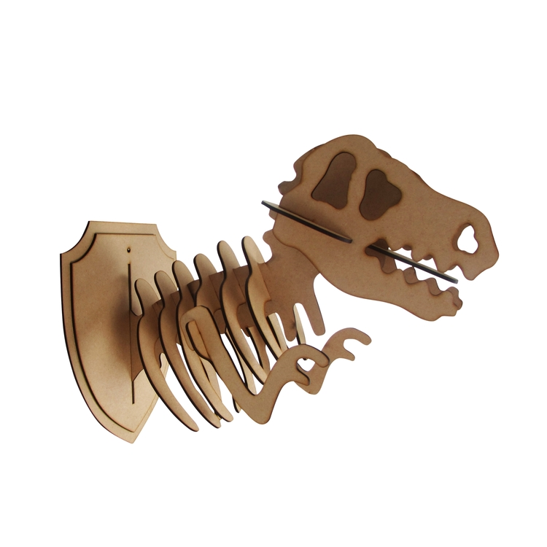The Dinosaur Wooden Animal Wall Mount is a fun and imaginative decor piece that brings a sense of adventure and nostalgia into any room. Crafted from high-quality wood, this mount features a detailed and stylized dinosaur head, often highlighting the sharp features and dynamic posture of the prehistoric creature. The natural wood finish adds an organic, rustic charm, while the unique design makes it a playful and eye-catching statement piece. Perfect for children’s rooms, game rooms, or anyone with a love for dinosaurs and whimsical decor, this wall mount adds a touch of prehistoric wonder to modern interiors.